Feature-based visual tracking for agricultural implements

Trevor P. Stanhope*, Viacheslav I. Adamchuk**

*McGill University, Montreal, QC (Tel: 514-398-8712; e-mail: trevor.stanhope@mail.mcgill.ca).
**McGill University, Montreal, QC (Tel: 514-398-7657; e-mail: viacheslav.adamchuk@mcgill.ca)
Abstract: Systems which utilize implement-mounted cameras for machinery feedback, such as row crop cultivators and sectional sprayers, can be upgraded to provide high-accuracy ground speed and tracking data using visual tracking algorithms. Vector data produced by visual tracking can be incorporated into control systems to compensate for implement dynamics in complement with RTK-GNSS receivers and other sensors. Variations of the SURF, SIFT, and ORB feature-descriptor algorithms were evaluated using a dataset of 640×480 pixel videos on six surfaces (gravel, asphalt, grass, seedlings, residue, and pasture) for speeds from 1 to 5 m/s. Feature-descriptor matching of consecutive video frames was tested using two methods of the k-Nearest Neighbors (kNN) algorithm: (1) 1NN with cross-checking, and (2) 2NN with the ratio-test. Ground speed and tracking direction were calculated using a fast histogram filter to reject outliers between frames. Compared to RTK-GNSS, ORB with CLAHE pre-processing (CLORB) and 1NN cross-checking was found to be the most robust with respect to real-time applications. For 95% of measurements, CLORB achieved an error of 0.23 m/s. Similar accuracy was achieved with SURF, U-SURF, and SIFT, but CLORB was capable of producing vector data in real-time (approximately 25 Hz), whereas SURF, U-SURF, and SIFT were only capable of 15 Hz or less.
Keywords: Computer-vision, feature description, visual tracking, control systems.

1. INTRODUCTION
An essential sensor feedback required by many agricultural control systems is real-time estimation of the vector data for the machinery. Several different techniques exist for acquiring vector data, each of which have advantages and disadvantages depending on the environment and required level of precision and accuracy.
For most applications, real-time kinematic (RTK) global navigation satellite system (GNSS) receivers are the preferred method for determining both vector and positional data of the vehicle. Field operations which require high accuracy and precision, such as tractor auto-steering, utilize RTK-GNSS receivers which are capable of up to 1 cm precision
(Gan-Mor, 2007). With respect to implements, the position of the toolbar relative to the tractor is dynamic, e.g. for pull-type and articulated-hitch implements, and therefore a secondary receiver is required on the implement itself, increasing the total cost. Another common method for determining ground speed is mechanical detection with rotary encoders in contact with the soil surface, commonly known as fifth-wheels. Fifth-wheels are advantageous because they are inexpensive and provide a sufficient degree of accuracy in many applications, e.g. seed metering. However, fifth-wheels are limited in that they only provide 2 degrees-of-freedom, i.e. acceleration and velocity along a single axis. Additionally, as contact sensors, fifth-wheels are prone to errors due to slippage on some agricultural surfaces, such as tilled soil (Tompkins, 1988).
Visual tracking using cameras is an alternative, non-contact approach which is unaffected by slip (Thansandote, 1977) and provides 4 degrees-of-freedom with a single camera (monocular) system. Visual tracking refers to the process of determining the movement of a vehicle by analyzing consecutive images captured by an on-board camera. Visual tracking is valuable for many robotics applications, such as simultaneous localization and mapping (Nistér, 2004), and can be incorporated into systems which utilize cameras for plant detection, such as inter-row cultivators or sectional sprayers. However, visual tracking is computationally intensive, and with respect to real-time applications, i.e. embedded systems, it is important that the tracking algorithm be accurate yet computationally efficient.
The goal of this study was to compare several visual tracking algorithms in the context of agricultural applications. Vector data of an agricultural vehicle was calculated for each algorithm for speeds from 1 to 5 m/s on six surfaces to assess its reliability with respect to computational efficiency, accuracy and robustness.
2. MATERIALS AND METHODS
2.1 Feature Detection and Description
A robust approach to visual tracking is to identify distinctive features which can be matched between consecutive images (Gauglitz, 2011). A feature, also known as a keypoint, is a sub-region of an image which exhibits maximum variation within its neighborhood. Keypoints are identified within an image using algorithms known as feature detectors. Once features have been located, each feature and its neighborhood must be described mathematically by a process known as feature description. After features and descriptors have been generated for both images, a classification algorithm such as k-Nearest Neighbors can be employed to find matches between the two sets of descriptors (Boiman, 2008).
2.2 SIFT
The Scale-Invariant Feature Transform (SIFT), proposed by Lowe et al. (2004), is a highly effective algorithm which incorporates both feature detection and description. SIFT is based on the Laplacian of Gaussian (LoG) which acts as a blob detector for features of different sizes by varying a scaling parameter (σ). However, LoG is computationally expensive, so the SIFT algorithm detects local extremas of the image by applying a Difference of Gaussians (DoG) filter as an approximation of LoG. SIFT is a very popular algorithm and performs with high accuracy compared to other feature-descriptors (Rosten, 2010).
2.3 SURF
Speeded-Up Robust Features (SURF) was developed as an improvement upon the SIFT algorithm (Bay, 2008). Similar to SIFT, SURF is a scale-invariant and rotation-invariant feature detector-descriptor based on LoG. Convolution with Gaussian second order derivatives in LoG is computationally expensive, so SURF improves computation speed by approximating LoG with box filters and using pre-computed integral images.
2.4 ORB
Oriented FAST and Rotated BRIEF (ORB) was created by Rublee et al. (2011) as a binary feature-descriptor algorithm with comparable performance to SIFT and SURF but faster computation speed. ORB uses the FAST feature detector to find keypoints, and then the Harris corner measure is applied to filter for the n-best points. For rotation-invariance, ORB assigns orientations to each FAST keypoint, a process known as Oriented FAST (oFAST). A second improvement in ORB was the inclusion of the Rotation-Aware BRIEF (rBRIEF) algorithm, a binary-descriptor algorithm based on BRIEF which adds integrates orientation into BRIEF keypoints by computing the intensity weighted centroid of a 15×15 region around each keypoint where the direction of the vector from each keypoint to its centroid gives its orientation.
2.5 CLAHE
Histogram equalization is a pre-processing technique for adjusting image intensity to enhance contrast and edge definition. However, global histogram equalization can cause degradation of some features. To address this, adaptive histogram equalization (AHE) partitions the image into equally-sized tiles, e.g. 8×8 tiles (Zuiderveld, 1994). For each tile, the sub-histograms are calculated and used to equalize each tile independently. However, AHE is still prone to amplification of noise in homogenous regions.
Contrast limited adaptive histogram equalization (CLAHE) was proposed by Pizer et al. in 1998 to mitigate noise amplification. CLAHE uses the slope of the transformation function in the neighborhood of a given pixel to perform contrast amplification whereby the amplification is proportional to the slope of the neighborhood's cumulative distribution function (CDF). CLAHE limits amplification by clipping the histogram at a predefined value, known as the clip limit, before computing the CDF. As a pre-processing technique, CLAHE significantly improves edge definition (Figure 1), but adds computational expense. CLAHE has been demonstrated to be an effective technique for real-time contrast enhancement (Yadav, 2014), and has been implemented in the histogram-binary combined corner enhancement (HBCCE) algorithm which was shown to improve the repeatability of feature detectors from 10% to 40% with negligible reduction in speed (El Harraj, 2015).
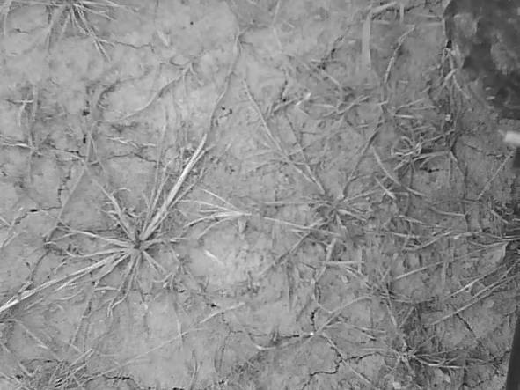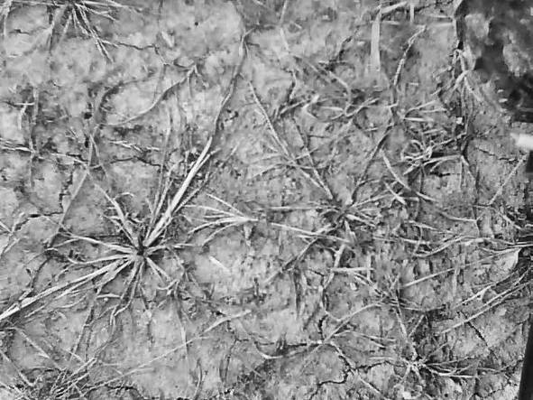
Fig. 1. Comparison of grayscale (left) and CLAHE (right).
2.6 kNN Matching
k-Nearest Neighbors (kNN) is a pattern matching algorithm commonly used in computer-vision. With respect to visual tracking, kNN is used to match keypoints based on the sets of descriptor vectors of two images. Applications of the kNN algorithm in computer vision commonly search for either one or two neighbors, referred to as 1NN and 2NN, respectively. Lowe et al. (2004) proposed the ratio-test to filter matches produced by 2NN where the distance metric of each neighbor is compared, and the match is accepted if the ratio between the two is less than a threshold (a ratio of 0.7 is typical). With respect to 1NN, a method known as cross-checking is often used to eliminate poor matches. Cross-checking is based on the principle that the distance from a point in a set (A) may be nearest to a point another in set (B), but when starting from the point in B, another point in A may be a nearer neighbor. Cross-checking computes 1NN for both directions, A-to-B and B-to-A, and a match is only accepted if points in both sets are nearest neighbors for both directions (Figure 2).
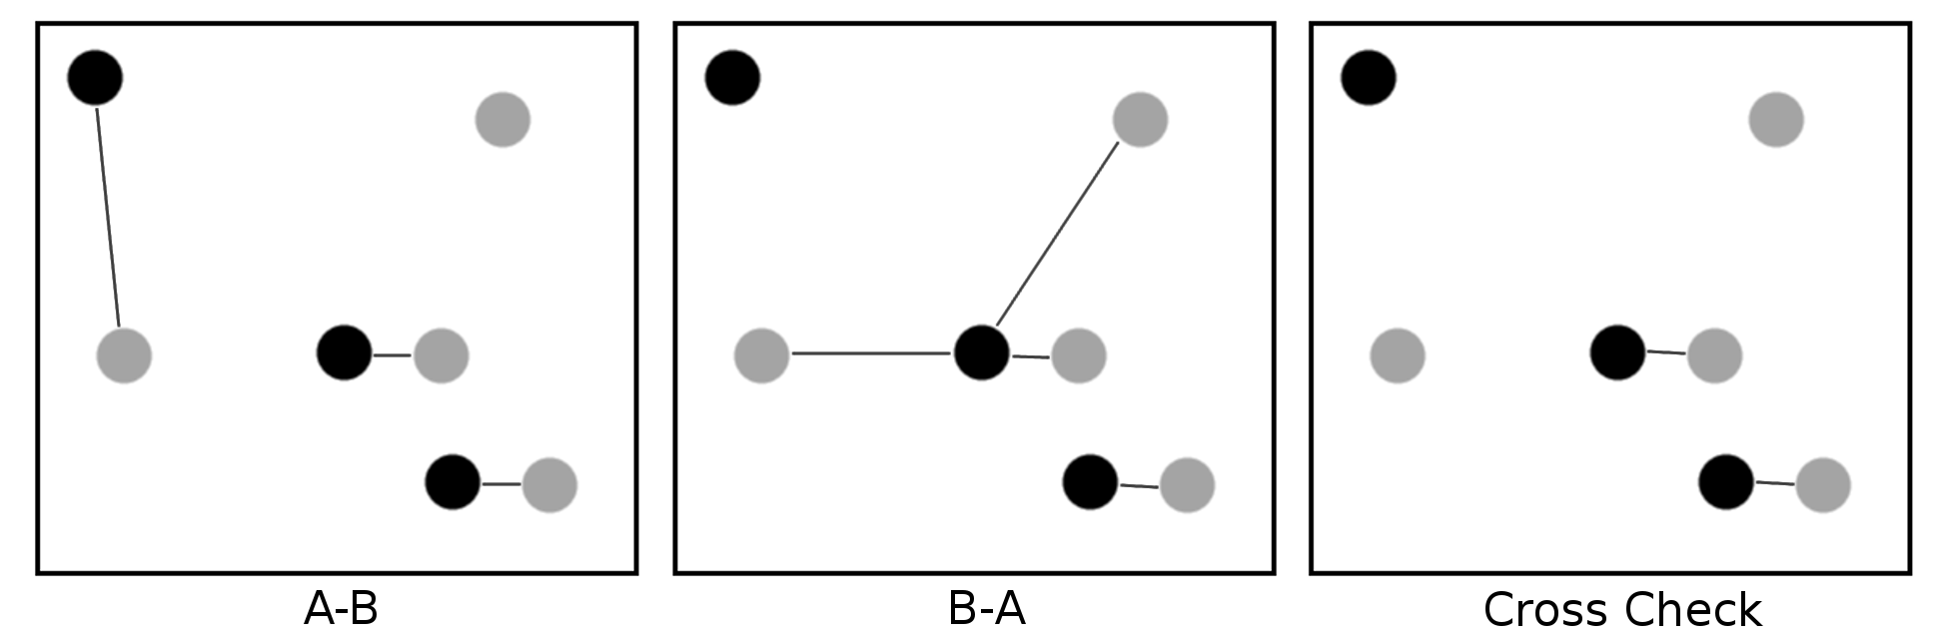
Fig. 2. Demonstration of 1NN matching with cross checking.
2.7 Experimental Setup
A weatherproof camera with a resolution of 640×480 pixels was mounted to the front of a John Deere 850D Gator (John Deere, Moline, Illinois, USA) at an orthogonal viewing perspective to the ground surface and a height of 1.0 m (Figure 3). The camera had an aperture of 2.4 (F), a 6 mm focal point (f), and a 8.47 mm (1/3 inch) color CMOS sensor with an aspect ratio of 4:3 (Shenzhen Yufei Technology Co., Shenzhen, China). To maximize the overlap between consecutive images at higher travel speeds, the camera was oriented width-wise such that the 640 pixel axis of the camera sensor was aligned with the direction of travel. The camera was capable of automatic white-balance adjustment and had a frame capture rate of 25 Hz.
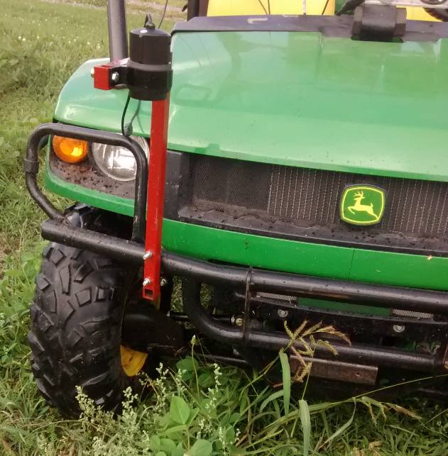
Fig. 3. Test vehicle and mounting bracket for camera.
After installation of the camera bracket, 10 calibration images were taken of a 9×7 checkerboard pattern in order to determine the camera distortion model. Corner detection was conducted on each image to find the geometric position of the 48 distinct corners. For each image, the corner points were used to fit a Brown-Conrady radial and tangential distortion model (1). The distance coefficients of each image were averaged to generate the distance coefficients used for radial and tangential distortion correction. Using the known dimensions of the squares (30 mm by 30 mm), a resolution of 1.0 mm/px was achieved with this configuration.
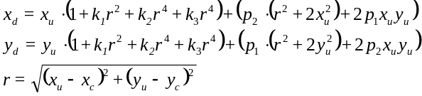 (1)
where radial terms k₁, k₂, and k₃ are -3.21×10¹, -6.03×10⁻³, and -3.22×10⁻³, respectively, and tangential terms p₁ and p₂ are -7.13×10⁻² and 2.41×10⁻⁷, respectively.
A Trimble AgGPS 542 RTK-GNSS rover receiver (Trimble Navigation Ltd., Sunnyvale, California, USA) was mounted to the test vehicle. The rover was configured to produce $GPVTG and $GPGGA NMEA-0873 strings at the maximum rate of 20 Hz. The accompanying base station was positioned in an open area, and all trials were conducted within 2 km of the base station. An application was developed using the Python programming language (vers. 2.7.11) (Python Software Foundation, Wilmington, Delaware, USA) and OpenCV (vers. 2.4.9) (Itseez, Inc., San Francisco, California, USA) to capture videos with low latency (less than 0.01 ms/frame) and generate accompanying RTK-GNSS logs with time-stamps corresponding to each image.
As specified by ISO 12188-2, the visual tracking system was evaluated from 1 to 5 m/s on six surfaces: asphalt, gravel, turf grass, seedlings, corn residue, and pasture (Figure 4).
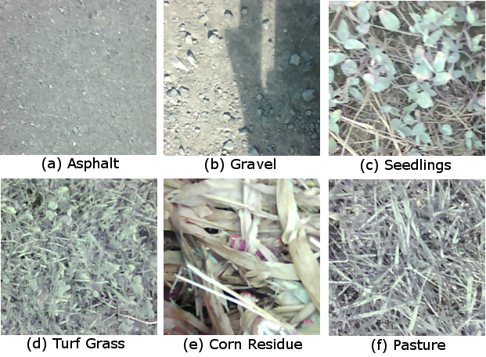
Fig. 4. Sample images for each of the six surfaces evaluated.
For each trial, the logging system and RTK-GNSS receiver were activated. Once an accurate satellite signal was acquired, the vehicle was engaged into gear and the accelerator was steadily applied until 5 m/s was reached, at which point the vehicle was decelerated back to rest. During each trial, the operator attempted to maintain an average acceleration of 0.25 m/s² and a trial duration of approximately 45 s. For each surface type, five replicates were conducted for a total dataset consisting of 32699 images.
2.8 Data Processing
The visual tracking algorithm consisted of nine sequential operations (Figure 5). First, the next RGB image was read from the camera buffer and then converted to gray-scale. In the case of CLORB, an additional pre-processing step of CLAHE was performed on the gray-scale image. Next, tangential and radial distortion of the image was corrected. Once rectilinear, the feature-descriptor algorithm was executed on the image to detect keypoints in the image followed by kNN to match keypoints of the current image with the those of the previous image stored in memory. Polar vectors were then computed from the displacement between matches, and a histogram vector filter was applied to eliminate outlier vectors. Lastly, the dominant vector direction and displacement was calculated using the set of all inlier vectors. All processing of the video data was computed in a single thread on a Intel Xeon E31225 at 3.1 GHz to simulate performance similar to a high-end embedded system.
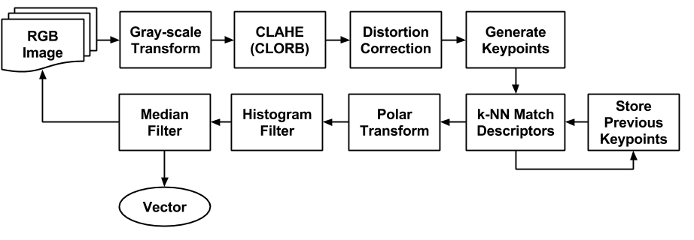
Fig. 5. Process diagram of the visual tracking algorithm.
Five feature-descriptor algorithms were evaluated: SURF,
U-SURF, ORB, ORB with CLAHE pre-processing (CLORB), and SIFT. Additionally, for each algorithm both 1NN with cross-checking and 2NN with the ratio-test (threshold of 0.7) were evaluated, for a total of ten configurations. With respect to SURF and U-SURF, common parameters discussed in the literature and by Bay et al. (2008) were used, specifically: four Gaussian pyramid octaves and two images within each octave of a Gaussian pyramid. As per the literature, kNN matching of SURF floating-point descriptors was conducted using the L² norm distance metric. With respect to SIFT, algorithm parameters similar to that used in Lowe et al. (2004) were used: the number of octave layers was set to 3, and the contrast and edge thresholds were set to 0.04 and 10, respectively. Again, kNN matching of SIFT floating-point descriptors was conducted using the L² norm distance metric. With respect to ORB, two variants were evaluated: ORB and ORB with CLAHE pre-processing (CLORB). Both algorithms were configured to use an edge threshold of 31, a patch size of 31, eight (8) pyramid levels, and two randomized pairs for BRIEF intensity comparisons. The kNN matching of ORB binary descriptors was conducted using the Hamming norm distance metric. In the case of CLORB, CLAHE with a clip limit of 2 and a tile grid size of 8×8 was used.
kNN matching for visual tracking is prone to non-parametric errors, therefore it is necessary to filter the set of all detected vectors to remove any outliers. With respect to visual tracking of orthogonal images, the set of motion vectors was assumed to be unimodal, so a computationally inexpensive histogram filter was employed (2). First, a 360 bin histogram (H) of θ-values was generated. Next, the discrete second-order gradient (3) of the histogram's cumulative summation (4) was used to calculate an array of differences (D). The centroid vector angle corresponding to the maximum value of the gradient array was found (θ_{C}) using the argmax function (5). The best estimate for the motion vector (v_{m}) between two consecutive frames was assumed to be the median and mean of the sets of all vector radii (R_{k}) and all vector angles (ϴ_{k}), respectively, for all vectors within a tolerance of 1˚ of θ_{C}:
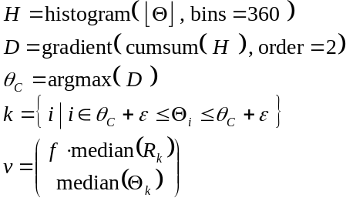 (2)
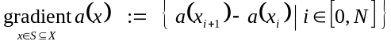 (3)
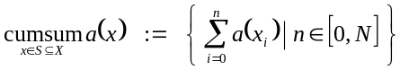 (4)
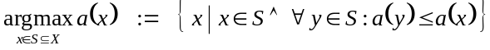 (5)
This approach was effective for determining the dominant vector even in the case of persistent shadows or non-moving objects in the field of view (e.g. the vehicle frame), and only required 2 ms per 640×480 image. Figure 6 shows an example of the histogram filter rejecting outlier vectors.
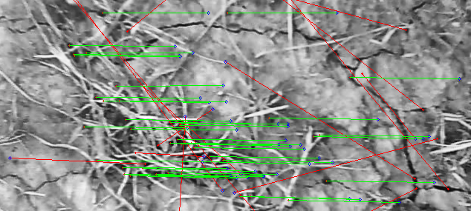
Fig. 6. Visual tracking with outlier vector filtering.
For subsequent analysis of the data, RTK-GNSS values were smoothed using a 5-point first-order Savitsky-Golay filter (SciPy vers. 0.17) in order to mitigate vibration effects on the antennae. To mitigate outliers produced by visual tracking, the groundspeed data was smoothed using a 5-preceeding-point median filter.
3. RESULTS
Figure 7 presents a comparison between two trials demonstrating the extremes of performance. In general, the feature-descriptors exhibited better performance on surfaces with more homogeneous coverage (e.g. seedlings) compared to heterogeneous surfaces (e.g. corn residue, pasture).
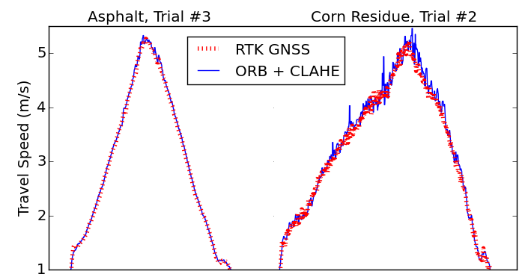
Fig. 7. Examples of trials which produced good (left) and bad (right) visual tracking.
Table 1 shows a summary of 95th percentile errors and average processing times for each feature-descriptor algorithm and matching method. By including CLAHE as a pre-processing step for ORB, error was lower at higher travel speeds compared to standard ORB.
Table 1. Summary of algorithms
 |  | 95th Percentile (m/s)
 | Hz | Overall | 1 - 2 m/s | 2 - 3 m/s | 3 - 4 m/s | 4 - 5 m/s
SURF₂₀₀₀  (1NN) | 8.7 | 0.29 | 0.17 | 0.22 | 0.30 | 0.35
SURF₂₀₀₀  (2NN) | 8.7 | 0.25 | 0.14 | 0.18 | 0.30 | 0.30
U-SURF₂₀₀₀ (1NN) | 15.1 | 0.24 | 0.16 | 0.17 | 0.25 | 0.29
U-SURF₂₀₀₀ (2NN) | 10.9 | 0.22 | 0.14 | 0.17 | 0.25 | 0.27
ORB₅₀₀  (1NN) | 34.2 | 0.25 | 0.13 | 0.16 | 0.40 | 0.32
ORB₅₀₀  (2NN) | 37.6 | 0.23 | 0.13 | 0.21 | 0.31 | 0.27
CLORB₅₀₀ (1NN) | 24.0 | 0.24 | 0.13 | 0.17 | 0.32 | 0.30
CLORB₅₀₀ (2NN) | 25.3 | 0.23 | 0.13 | 0.18 | 0.27 | 0.27
SIFT₅₀₀  (1NN) | 5.5 | 0.21 | 0.13 | 0.15 | 0.22 | 0.29
SIFT₅₀₀  (2NN) | 5.4 | 0.21 | 0.13 | 0.16 | 0.23 | 0.26
Note: subscript values indicate the keypoint threshold, i.e.
n-features with respect to SIFT and ORB, or the Hessian threshold with respect to SURF. This table presents thresholds which resulted in the best overall performance with respect to both computation speed and accuracy.
Figure 8 presents the normalized frequency of errors for visual tracking compared to RTK-GNSS data. Two curves are presented: 1) uncompensated, and 2) depth compensated using a constant conversion factor based on surface height (7). Gravel, asphalt, and seedlings showed negligible differences in error between the uncompensated and depth compensated methods.
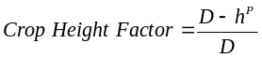 (7)
where P is the zoom power (1.0918), D is the ideal subject depth (100 cm), and h is the crop height (in cm).
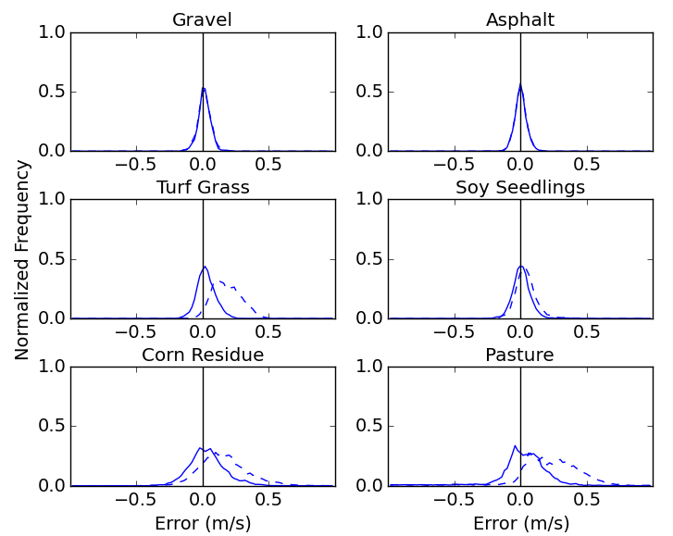
Fig. 8. Normalized frequency of errors for uncompensated (dashed) and depth compensated (solid).
Figure 9 presents Tukey HSD multiple comparisons of RMSE values with respect to surface. Pasture and asphalt resulted in significantly greater variance for SURF, U-SURF, and ORB. CLORB and SIFT had significantly lower variance than the other algorithms.
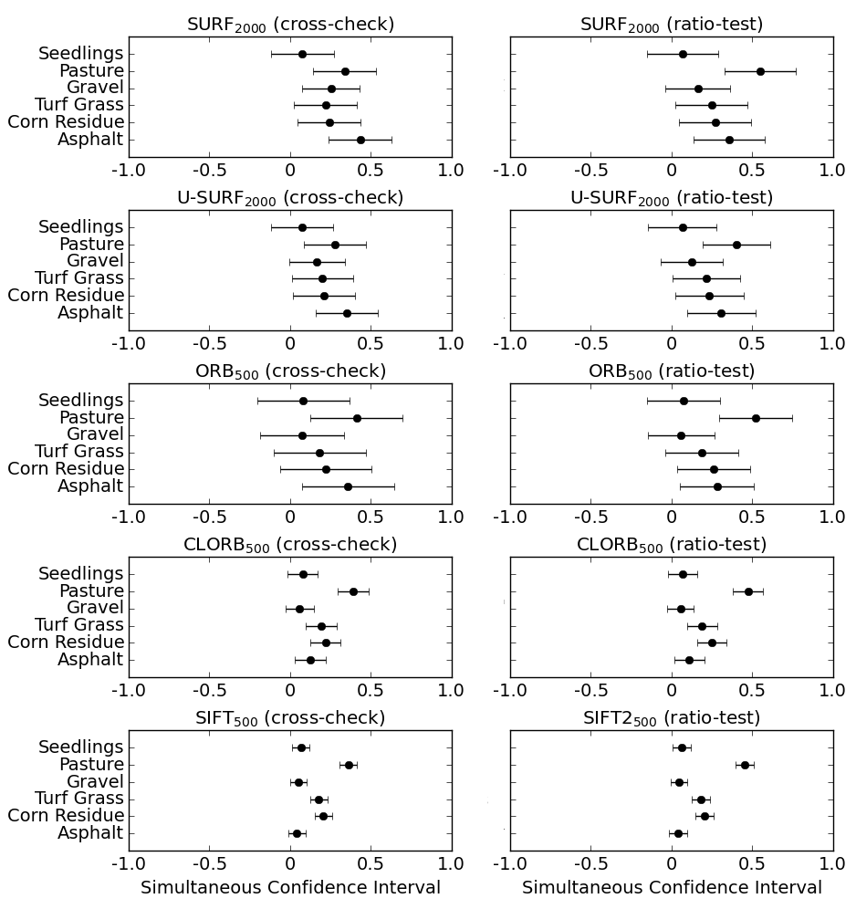
Fig. 9. Tukey HSD multiple comparisons of RMSE values.
Figure 10 presents the inlier-outlier ratio, i.e. the ratio of valid matches to total matches. In general, 1NN with
cross-checking had less variance than 2NN with the ratio-test.
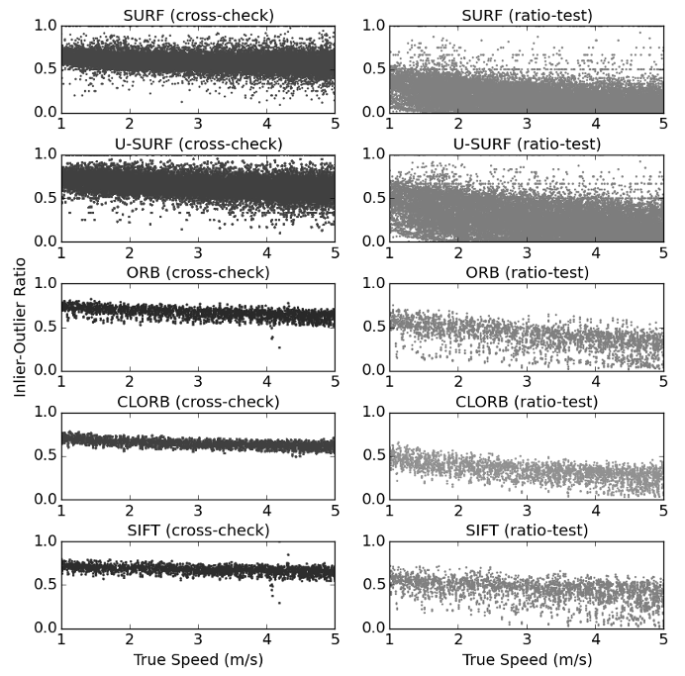
Fig. 10. Inlier-outlier ratio with respect to kNN method.
4. DISCUSSION
Although the ORB algorithm was computationally efficient, it demonstrated lower accuracy for speeds from 3 to 5 m/s compared to SIFT, SURF, U-SURF, and CLORB (Table 1). The SIFT algorithm exhibited the best overall accuracy (Figure 9), but the slowest computation speed (Table 1). CLAHE improved the reliability of the ORB algorithm and, despite the increased computational cost, achieved 25 Hz average computation speed (Table 1). With respect to kNN matching, 2NN with the ratio-test produced more accurate estimates (Table 1), but lower inlier-outlier ratios and images without matches (Figure 10). In general, the accuracy of all algorithms decreased with higher ground coverage (Figure 8).
These results demonstrate that real-time visual tracking systems should consider CLORB with 1NN cross-checking due to its compromise between accuracy and speed. However, systems which do not have strict constraints might consider SIFT with 2NN ratio-testing due to its high accuracy on all surfaces. For example, SIFT would be ideal for tractor performance testing on concrete or asphalt because it produces distinct keypoints despite surface homogeneity.
4.1 Future Research
Visual tracking on inter-row cultivators may help compensate for the dynamic position of the implement relative to the tractor. Computer vision row detection has been successfully used on center-shift hitches (Hague, 2006), but pivoting-hitch systems, e.g. the Sunco AcuraTrak (Sunco Manufacturing, North Platte, Nebraska, USA), are challenging due to the hitch changing the orientation of the cameras relative to the crop row. Pivoting-hitch guidance errors may be mitigated by compensating for yaw with vector data. Assuming that the longitudinal component of the velocity in the direction of the row is much greater than the lateral component, the small-angle approximation applies and the image can be corrected with a rotational transformation about the pivot point.
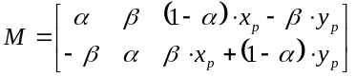 (8)
where α = cos(θ), β = sin(θ), and (x_{p}, y_{p}) is the pivot-point.
Monocular visual tracking may also be a viable method for crop height detection instead of ultrasonic (Gil, 2007). By determining the ratio between uncompensated visual tracking vector data and RTK-GNSS groundspeed, crop height could be inferred on systems which already incorporate monocular computer vision, such as sectional sprayer control systems.
5. CONCLUSIONS
Real-time visual tracking has good potential for agricultural implement feedback on surfaces without high ground coverage and at lower ground speeds. When compared to RTK-GNSS, CLORB with 1NN cross-checking was the most robust with respect to real-time applications, and achieved 95th percentile error of 0.23 m/s. These results suggest that applications which utilize low-cost cameras should consider CLORB due to its compromise between accuracy and speed.
REFERENCES
Bay, H., Ess, A., Tuytelaars, T., & Van Gool, L. (2008). Speeded-up robust features (SURF). Computer vision and image understanding, 110(3), 346-359.
Boiman, O., Shechtman, E., & Irani, M. (2008, June). In defense of nearest-neighbor based image classification. In Computer Vision and Pattern Recognition, 2008. CVPR 2008. IEEE Conference on (pp. 1-8). IEEE.
El Harraj, A., & Raissouni, N. (2015, January). Histo-binary combined corner enhancement (HBCCE) improved algorithm for image processing corner detection. Proc. of the International Conference on Image Processing, Computer Vision, and Pattern Recognition (IPCV), 95-101.
Gan-Mor, S., Clark, R.L., & Upchurch, B.L. (2007). Implement lateral position accuracy under RTK-GPS tractor guidance. Computers and Electronics in Agriculture, 59(1), 31-38.
Gauglitz, S., Hèollerer, T., & Turk, M. (2011). Evaluation of Interest Point Detectors and Feature Descriptors for Visual Tracking. International Journal of Computer Vision, 94( 3), 335-360.
Gil, E., Escolà, A., Rosell, J.R., Planas, S., & Val, L. (2007). Variable rate application of plant protection products in vineyard using ultrasonic sensors. Crop Protection, 26(8), 1287-1297.
Hague, T., Tillett, N.D., & Wheeler, H. (2006). Automated crop and weed monitoring in widely spaced cereals. Precision Agriculture, 7(1), 21-32.
Lowe, D. (2004). Distinctive image features from local scale-invariant keypoints. International Journal of Computer Vision, 60(2), 91-110.
Nistér, D., Naroditsky, O., & Bergen, J. (2006). Visual odometry for ground vehicle applications. Journal of Field Robotics, 23(1), 3-20.
Pizer, S. M., Johnston, R. E., Ericksen, J. P., Yankaskas, B. C., & Muller, K. E. (1990). Contrast-limited adaptive histogram equalization: speed and effectiveness. Proc. of the First Conf. on Visualization in Biomedical Computing, 337-345.
Rosten, E., Porter, R., & Drummond, T. (2010). Faster and better: A machine learning approach to corner detection. Pattern Analysis and Machine Intelligence, IEEE Transactions on, 32(1), 105-119.
Rublee, E., Rabaud, V., Konolige, K., & Bradski, G. (2011). ORB: an efficient alternative to SIFT or SURF. IEEE International Conf. on Computer Vision, 2564-2571.
Thansandote, A., Stuchly, S.S., Mladek, J., Townsend, J.S., & Shlosser, H. (1977). A new slip monitor for traction equipment. Transactions of the ASAE, 20(5), 851-856.
Tompkins, F.D., Hart, W.E., Freeland, R. S., Wilkerson, J.B., & Wilhelm, L.R. (1988). Comparison of tractor ground speed measurement techniques. Transactions of the ASAE, 31(2), 369-374.
Yadav, G., Maheshwari, S., & Agarwal, A. (2014). Contrast limited adaptive histogram equalization based enhancement for real time video system. Communications and Informatics International Conference on Advances in Computing, 2392-2397.
Zuiderveld, K. (1994). Contrast limited adaptive histogram equalization. Graphics gems IV, 474-485. Academic Press Professional, Inc..

